# Beyond size: evolutionary patterns of non-allometric shape variation and divergence in a highly allometric clade of murine rodents

Ariel E. Marcy1,2*, Thomas Guillerme,3, Matthew J. Phillips4, and Vera Weisbecker2,5

**Affiliations:** 1University of Nebraska-Lincoln, School of Biological Sciences, Hall 402 1104 T St Lincoln, NE 68588-0118, USA; 2University of Queensland, School of Biological Sciences, St. Lucia, QLD 4072, Australia; 3University of Sheffield, Department of Animal and Plant Sciences, Alfred Denny Building S10 2TN, United Kingdom; 4Queensland University of Technology, School of Biology & Environmental Science, Brisbane, Queensland, 4000 Australia; 5Flinders University, College of Science and Engineering, Bedford Park SA 5042, Australia; *amarcy2@unl.edu

## Abstract (limit 350 words)

**Background:** Mammalian cranial diversity reflects its function in carrying a large brain while acquiring food and sensory information. As a result, selection on these traits appears to cause common evolutionary shape patterns. Craniofacial evolutionary allometry (CREA) is a well-known evolutionary pattern for mammals in which larger species have longer rostra and proportionally smaller braincases compared to related species. The mechanisms behind CREA are not yet established but hypotheses include stabilizing selection on function as cranial shapes scale at different proportions when body size changes (i.e. allometry). Australian murid rodents are known for exceedingly conserved CREA, even in specialist species, making them a model system for investigating mechanisms reinforcing CREA.

**Results:** We tested CREA in 37 species with 3D geometric morphometrics by quantifying cranial morphology, modularity, integration, and morphological distances between species in both allometric and allometry-free datasets. We assessed if the allometry-free datasets showed patterns that appeared independent of CREA, particularly in specialists. The positions of specialists in the allometry-free morphospace and a result for global integration suggest that stabilizing selection integrates posture with gnawing function. Carnivorous rodents, which have lost gnawing functionality, were the most anomalous while a species with the highest facial tilt consistent with bounding locomotion remained on the common evolutionary line. Unexpectedly, the second major allometry-free axis captured CREA-like shape patterns and separated species with allometries parallel to the common evolutionary line yet y-intercept shifted. These shifts correspond with more robust or gracile crania than expected for their body size, apparently facilitating divergent cranial shapes adapted to folivory and bipedal hopping, respectively, in an highly allometric clade.

**Conclusions:** The allometric and allometry-free datasets identify three main mechanisms appearing to produce cranial diversity in an allometrically constrained clade. First, allometric facilitation along the common evolutionary line which integrates most variations in cranial posture. Second, a release from stabilizing selection on gnawing function, supporting previous work finding exceptions to CREA among functional outliers. Third, and uniquely, we find a correlation between integration of non-allometric variation driving visible y-intercept shifts. The subsequent CREA-like patterns in the allometry-free dataset shows that CREA can be modified by mechanisms other than allometry.

**Keywords:** allometry, CREA, geometric morphometrics, integration, modularity, Muridae, stabilizing selection

## Background

The skull is arguably the most functionally diverse interface between a mammal and its environment. It is employed in the acquisition and mastication of food, receives the majority of sensory input, and carries the large and heavy brain. The evolution of mammalian cranial diversity is therefore assumed to be heavily influenced by the various requirements on the skull. Possibly for this reason, cranial morphology across mammals displays some common patterns of evolutionary variation. The most widely discussed of these is the tendency of larger mammals to display longer rostra and smaller braincases relative to smaller species, particularly in closely related species [1]. This pattern, termed craniofacial evolutionary allometry (CREA), has been found in a diverse range of vertebrates representing 11 different orders, especially those of placental mammals but also some marsupials [2–4].

Mitchell et al. (202x) challenged the assertion of a ubiquitous CREA pattern across mammals and reasoned that the frequently observed pattern is often a product of bite force allometry and phylogenetic niche conservatism. More closely related species tend to have more similar ecology and behaviour; however, larger species can also generate the same absolute bite force as smaller species with reduced relative bite force demand on their larger facial skeletons. Therefore, if related species share common dietary regimes or biting behaviours, larger species can sacrifice some capacity for bite force generation in their craniofacial architecture in favour of alternative selective pressures. Under this assumption, morphological shifts in cranial morphology are only predicted in association with substantial changes in dietary material properties, regardless of body size.

Among mammals, rodent skulls are one of the most striking cases of strong allometry coinciding with a CREA pattern of shape variation. A recent study (Marcy et al. 2020) showed that a sample of mostly Australian rodents, diverging as early as ten million years ago, have a highly conserved slope of allometry explaining over a third of their overall shape variation. The shape variation explained by allometry is also aligned with CREA, both in the definition adopted in Marcy et al. (2020; referring to a longer/elongated rostrum/muzzle/snout) and Mitchell et al. (202x; referring to hyperallometric gracilization more generally). This supports previous work suggesting that the strong allometry occurs as a result of stabilizing selection on the rodent gnawing apparatus, which is complex and highly adaptive for omnivory [7, 10]. It might also explain the clade’s unique overall shape but slow-evolving morphological evolution through time (Goswami et al. 2023). Support for this comes from developmental evidence suggesting that cranial growth – which is by definition allometric – varies substantially, such that similar specialisations can arise from different growth patterns (Beaver/muskrat paper, Wilson 2013). Moreover, Marcy et al.’s (2021) work showed that species whose shape appeared most distinct from the common evolutionary allometric pattern tended to be ecological specialists with distinct diets and locomotor modes [7]. This is consistent with Mitchell et al.’s (2023) hypothesis that CREA patterns disappear when dietary hardness changes, and also highlights that patterns of variation beyond allometric scaling are worth investigating on their own.

Assessing the impact and scope of cranial adaptation in situations where CREA appears to be the dominant pattern has the potential to clarify the origins of CREA, and also the conditions under which adaptations can be superimposed over CREA patterns of shape variation. The rodent sample assessed in Marcy et al. (2020) offers an ideal opportunity because it combines allometrically highly uniform species with specific deviations from the common pattern. These include the carnivorous rodents, but also a group of ecological specialists with a distinct non-diet related locomotor mode, the hopping mice *(Notomys*) and the rabbit-rat (*Conilurus penicillatus*). The latter group is of interest because of their conspicuous “facial tilt” of the anterior cranium, an adaptation resulting in an expansion of their field of view while hopping or bounding [12]. This makes hopping and bounding species intriguing cases to examine in the allometry-free morphospace as their rostral shapes may depend on the degree to which the facial tilt is independent from CREA.

Selection on functional shapes that are independent of CREA is expected to be most apparent in some parts of the skull but not others (e.g. the maxillary region of carnivorous species; the back of the skull in hopping or bounding species). A key question is therefore how different parts of the skull co-evolve, and whether there are size-independent different patterns alongside CREA which allow the evolution of skull parts away from the main allometric line. This is conceivable because allometry explained a large amount (36%), but not the majority, of cranial shape variation [7], leaving substantial residual variation that might be attributable to non-CREA patterns. Understanding how the different parts of the cranium relate to each other in evolution can be investigated using assessments of variation within anatomical regions of the skull, known as modules, which are linked due to shared genetic or developmental mechanisms [13]. This allows assessment of integration (covariation between modules; [13]) and modularity (the degree of independence of shape variation within a module relative to the others; [13]). These can be calculated in both the allometric morphospace and in the ‘allometry-free’ shape morphospace where the allometric component of shape has been removed from species mean shapes, leaving only the shape residuals. Strong allometry in the rodent sample means that we should expect all parts of the skull to evolve changes in shape as one structure, which corresponds with low modularity (i.e. no differences in evolutionary behavior across modules) and high integration between modules (i.e. all modules co-varying strongly, also known as global integration) [13, 14]. Conversely, if the allometric pattern is paired with an underlying ability to change relative to CREA, we would expect higher modularity (where parts of the skull evolve independently of each other) and lower integration between modules (where modules co-vary less), particularly in the allometry-free space.

Another avenue for investigating the impact of allometry on rodent skull diversification is visualizing the evolution of cranial shape disparities through time in allometric and allometry-free contexts. In particular, if the shape residual variation relates to the capacity of the rodent skull to diverge independently of allometry, we would expect to see greater relative morphological distances involving species with non-CREA skull adaptations in the allometry-free dataset compared to the full shape dataset. In other words, we would expect to see the highest morphological distances between species that have ecological specializations with divergent functional requirements compared to those whose shapes follow the expected CREA pattern.

In this study, we test the above predictions based on Marcy et al. (2020)’s sample of 37 rodent species to assess the impact of non-allometric selection on an ecologically diverse sample of murid rodent species in an allometry-free morphospace. We ask if the removal of size from the dataset completely removes variation due to CREA; whether the allometry-free dataset confirms our prediction of higher modularity and lower integration of cranial modules; and whether size-independent shape variation should show maximum shape disparity occurring between distantly-related species and/or species with divergent functional requirements (as opposed to allometric shape spaces, where, maximum shape disparity should occur between species with divergent body sizes).

## Methods

We used a previously published dataset (n = 317; Marcy et al. 2020) of 37 Australian rodent species that were landmarked with a protocol of 60 fixed landmarks, 141 curve semi-landmarks, and 124 patch semi-landmarks. Ecological information on diet and locomotion for each species was taken from Breed and Ford (2007). For details, see Marcy et al. (2020). All analyses were performed in R (v.3.6.1) (R Core Team 2019) **[RUN UPDATE],** using the packages *geomorph* [VERSION AND REF], LandvR [VERSION AND REF]*,* and *vegan* [VERSION AND REF]*.*

### Comparing distribution of species in morphospace through PCA scores

In order to visually assess the allometric and non-allometric morphospaces, we performed principal component analyses (PCA) on three different shape datasets of mean species shapes, and visualized each morphospace with plots of the first two principal components (PCs). The first, termed here ‘full shape dataset’ is based on a conventional generalized Procrustes analysis, and includes the allometric component of shape. Second, the ‘shape residual dataset’, includes the components of shape that remain once allometric shape is removed and it provides a ‘size-less’ or ‘allometry-free’ comparison of the mean species shapes. The shape residuals were obtained from a phylogenetically-informed linear generalized least squares model using random permutations implemented by the RRPP package. When residuals wereadded to the consensus shape derived from the GPA, the shape variationcould be compared visually to the full shape dataset. Third, we repeated the PCA for the shape residual dataset after removing the four hopping mice (genus *Notomys*). We did this because we expected their bipedal posture to exaggerate some features of shape variation in the PCA and the resulting morphospace plots.

To assess morphospace similarity between the full shape and shape residual datasets, we performed a Mantel test using the *vegan* function *mantel* [16] on the distance matrices of all PC scores in each dataset. We also use simple correlation to assess the relationships between allometric shape variation and individual morphospace axes, because the full shape PC1 is highly correlated with allometric shape variation in this dataset (r = 0.92; Marcy et al. 2020). Therefore, we calculated the same correlation for the full shape PC2 and the shape residual PCs to confirm that these morphospace axes capture shape variation independent of allometry and to confirm that the allometry-free dataset lacks allometric information.

### Assessment of allometric vs. allometry-free shape variation via heat maps

In order to visualize and assess allometric shape variation in the full shape dataset, we created heatmaps showing the magnitude of landmark displacements using *landvR* functions [9, 17]. We compared three different visualizations of allometry. First, using fitted allometric shapes estimated by Procrustes linear models (also using random permutations as per RRPP) across the entire sample. However, variation characterized through ordination or allometric analysis provides summaries of parts of the variation, which do not always reflect actual specimens [9]. We therefore also visualized the mean configurations of the smallest native species (the delicate mouse, *Pseudomys delicatulus*) and the largest (the giant white-tailed rat, *Uromys caudimaculatus*), as determined by mean centroid size. Third, to illustrate the similarity in shape variation along PC1 to the two previous visualizations of allometric variation, we visualized the hypothetical shapes for PC1 minimum and maximum.

To compare the allometric shape change to the ‘isometry-free or ‘allometry-free’ shape variation, we produced heatmaps from the shape residual dataset visualizing the minimum and maximum hypothetical shapes for three different PC axes. First, we produced heatmaps for PC1 and PC2 to compare the allometry-free changes to the allometric cranial changes seen in the full shape dataset. We also visualized heatmaps for the shape residual PC2 without the four species of *Notomys* in order to assess the impact of their bipedal posture on the ordinated shape variation.

### Modularity and integration in allometric and allometry-free datasets

To compare the modularity patterns across our allometric and non-allometric datasets, we assumed a five-module framework that followed the six-module framework found across therian mammal crania [18] but excluding the zygomatic arch module, which was missing due to scanner limitations (Marcy et al. 2018). To quantify modularity, we used the *geomorph* function *phylo.modularity* [19, 20]. The calculates the covariance ratio (CR) coefficient, a ratio with the numerator as covariation between modules and the denominator as covariation within modules [19]. Therefore, highly modular structures, with higher covariation within than between modules, will have small CR values within the unit interval [19]. By contrast, structures with low modularity will have CR values close to 1.0 because the two covariation values are very similar [19]. The function provides a phylogenetic context by generating a matrix of partial least squares under a Brownian motion model of evolution [21] that was informed by our time-calibrated ultrametric molecular phylogeny (Smissen and Rowe 2018, Marcy et al. 2020). The resulting evolutionary covariance matrix controls for similarities between closely related species, which is needed to study macro-evolutionary patterns of modularity [21, 23]. Significance was determined by randomly resampling the modules 1,000 times and comparing the random distribution of CR coefficients to the observed value.

In order to assess whether the modularity and integration patterns are consistent with CREA or any other pattern, we used the *vegan* function *mantel* to perform pairwise Mantel tests on the distance matrices of PC scores within each module [24]. The resulting *r* statistics indicates the degree of correlation between each module pair, with values closer to one corresponding to higher integration [25]. If a module consistently has *r* statistics closer to zero, this indicates higher modularity, i.e. greater independence in shape variation relative to the other cranial modules. The Bonferroni correction was used to adjust for multiple comparisons (Bonferroni 1936).

Finally, we tested for global integration of the crania in both the full shape and shape residual datasets using the *geomorph* function *globalIntegration* based on Bookstein (2015). This test distinguishes between integration and a null hypothesis for self-similarity, which is the absence of any interpretable change at any spatial scale. Self-similarity in a morphological dataset is the spatial equivalent of a temporal random walk based on Brownian motion (Bookstein 2015). The degree of integration versus self-similarity is quantified by the regression slope between the entire sample’s (n = 317) bending energy and its partial warp variance (Bookstein 2015; Evans et al. 2017; Young et al. 2017; Sansalone et al. 2019). The null expectation of self-similiarity would give a regression slope of -1 so if the slope is steeper – i.e. greater absolute value – this indicates global integration due to low independence in each cranial module relative to the other cranial modules.

### Phylo-morphological distance

Since the constraints on shape disparity from integration may differ in the allometric and allometry-free morphospaces, we visualized the relationship between pairwise phylogenetic and morphological distances for the full shape and shape residual datasets. We retrieved a matrix of pairwise phylogenetic distances using the *picante* function *cophenic* [27] on our ultrametric time-calibrated phylogeny (Smissen and Rowe 2018; Marcy et al. 2020). Values were divided in half to give values in millions of years since last common ancestor. The pairwise Procrustes distances – i.e. morphological distances – derived from the GPA of shapes. We then plotted every pairwise combination of the phylogenetic and morphological distances between two species in our dataset for both the full shape and shape residual datasets. We expect this to provide a broad estimate of morphological divergences with and without allometry, but there are two caveats to this method: 1) pseudoreplication due to the high volume of pairwise comparisons within the sample and 2) non-uniform sampling of time due to the phylogeny’s structure, with most coverage occurring between 0.3-4.2 Ma. We therefore interpret the results with these caveats in mind.

## Results

### Principal component analyses

We visually assessed whether removing allometry emphasizes different morphological patterns in the rodent crania morphospace by comparing PC1/PC2 plots and an evolutionary allometry plot of the full shape dataset (with allometry, Fig. 1a-c) to PC1/PC2 plots of the shape residual dataset (allometry-free, Fig. 1d-f). As expected, the allometry-free shape residual dataset captured less shape variation along PC1: 26.8% compared to 52% in the full shape dataset (see also Fig. S1). The PC2 axes captured similar percentages of shape variation, 14.5% and 18.6%, within the full shape and shape residual datasets, respectively. As expected, the full shape PC1 orders species by size (correlation with centroid size is 0.92; Fig. 1a vs. b), whereas neither residual shape PC1 nor PC2 distinguishes between large-bodied and small-bodied species(Fig. 1c vs. d). The divergent bipedal posture of *Notomys* was not a main driver of residual shape variation: when *Notomys* was removed, the relative positioning of species and the shape variation associated with the first two PCs remain very similar (Fig. 1d vs. e).

The species distribution along the full shape PC2 resembles the pattern along the residual shape PC1 (Fig. 1a vs. f). Both axes show the carnivorous *Xeromys myoides* and *Hydromys chrysogaster* at one extreme and a quadrupedal bounding species(the brush-tailed rabbit rat, *Conilurus penicillatus*) at the other. A correlation of 0.97 confirms the similarity between the full shape PC2 and the residual shape PC1 axes while the Mantel correlation between the two morphospaces is comparatively lower at 0.58. However, removing the full shape PC1 – and the allometric variation it captures – from the full shape morphospace and then re-performing the Mantel correlation test raises the r statistic to 0.94. This confirms that PC1 mostly captures allometric variation while the other PCs preserve other shape patterns. Nevertheless, the relationship between the full shape and shape residual axes is not always PC(n) to PC(n-1). For example, the correlation between full shape PC3 and shape residual PC2 is 0.25. This supports our expectation of the ordinations summarising different dominant patterns of shape variation in the allometry-free shape residual dataset compared to the full shape dataset.

In the shape residual plot of PC1 and PC2, the majority of species cluster in the center, which is expected because the main differentiator of shape – size – is now removed. This includes the two large-bodied frugivores, which have high PC1 scores in the full shape plot and high regression scores in the evolutionary allometry plot. The allometry-free shape residual plots highlight other ecological specialists instead, such as the two semiaquatic carnivores along PC1 and the four hopping *Notomys* species along PC2 (Fig. 1f). The PC2 maximum highlights the Australian murid most specialized for folivory, the broad-toothed rat (*Mastacomys fuscus*). All of the specialists along these extremes are in the Pseudomys division (*sensu* [22]), a clade of five genera from the earliest radiation of extant Australian rodents [28], represented here by shades of blue (legend in Fig. 1c). In the full shape dataset, most of these specialists show a degree of deviation from the common allometric line (Fig. 1b,f). The two carnivores and a specialist folivore (*Mastacomys*) plot above the line while *Notomys* appears to have a lower y-intercept for their genus-wide evolutionary allometric trajectory compared to other murids.

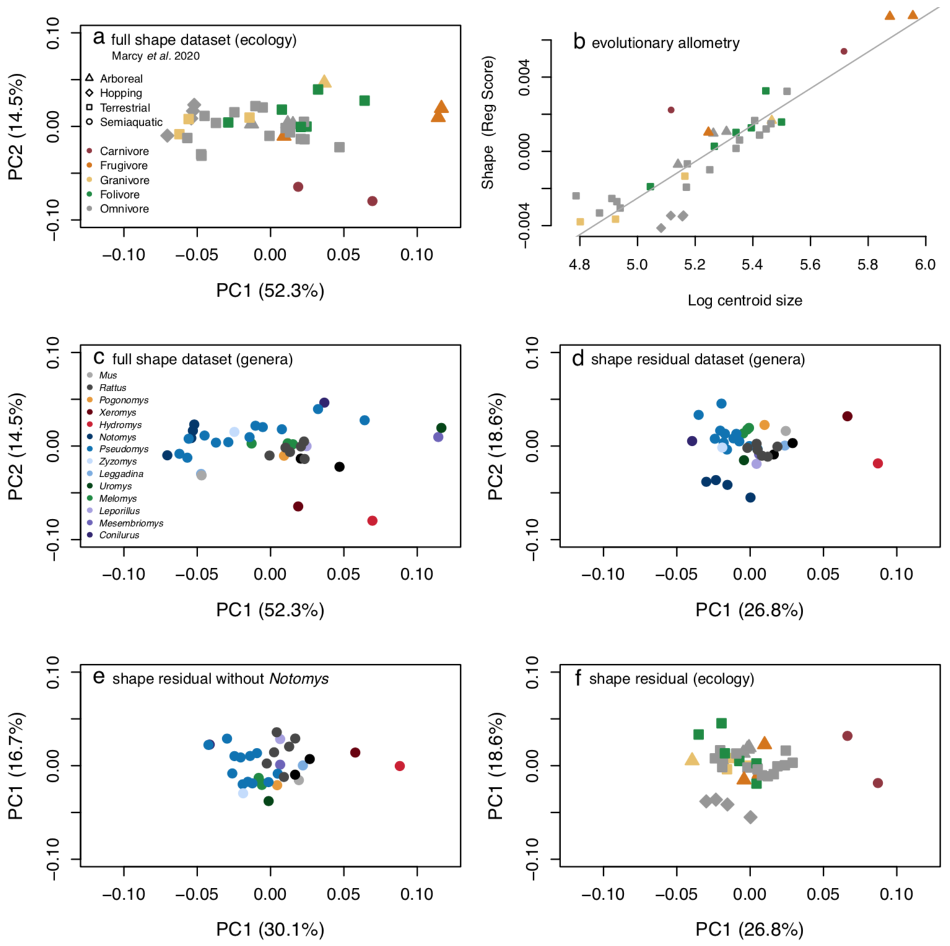

**Figure 1:** Differences between the hypothetical shapes captured between PC1 extremes.a, plot of PC1 and PC2 for the full shape dataset and b**,** plot of log centroid size versus the projected regression score with a gray regression line indicating the common evolutionary trajectory; data from Marcy et al. (2020) but with point shapes by locomotion and colors by diet. c,part a with point colors by genera (*Mastacomys* is within genus *Pseudomys*). d, ‘allometry-free’ shape residual dataset, e**,** shape residual dataset without *Notomys,* f, part d with point shapes by locomotion and colors by diet.

### Landmark heatmaps

As expected, all a CREA pattern is apparent in the visualization of shape variation that is associated with allometry: fitted minimum/maximum shapes, mean shapes of smallest/largest species, and shapes on the extremes of PC1 (Fig. 2a-c). Representations of larger species had lengthened rostra and smaller relative braincases compared to smaller species.

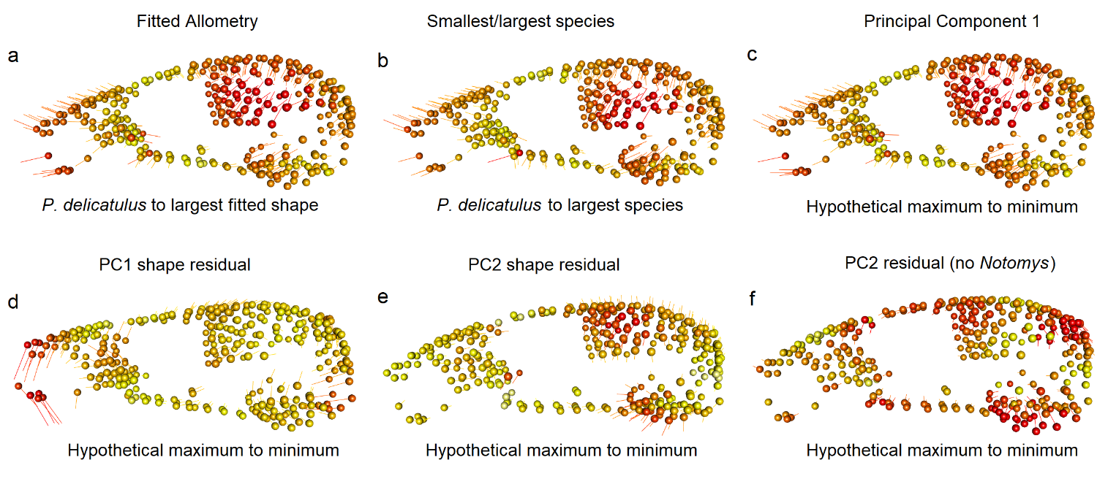

**Figure 2:** Landmark heatmaps shape variation. Spheres show the mean position of landmarks for the column’s dataset, vectors show landmark displacement. Colors and lengths are calculated from relative proportions of the minimum/maximum vector lengths for each comparison, and are not equivalent across columns. a, shape differences between the shape fitted for the smallest Australian native (*P. delicatulus* to the largest species in the sample (*U. caudimaculatus)*; b, shape differences between the mean shapes of these previous species, showing high correspondence to differences between hypothetical allometric fitted shapes; c, differences between the hypothetical shapes captured between PC1 extremes; d, differences between the hypothetical shapes captured between PC1 extremes based on allometry-free data; e, differences between the hypothetical shapes captured between PC2 extremes on allometry-free data; f, differences between hypothetical shapes between PC1 extremes after removing *Notomys.*

Removing the shape patterns that covary with size (Fig. 2d-f) also removed CREA. Species closer to the PC1 minimum show ventral flexion of the rostrum and anteroventral movement of the foramen magnum (Fig. 2d). The allometry-free shape residual PC2 heatmaps with all species highlighted shape patterns resembling the allometric variation seen in the full shape PC1 even though this pattern is not allometric, i.e. not correlated with body size (correlation = 0.11). For example, the *Notomys* species at PC1 minimum show enlarged braincases and auditory bullae, but not shortened rostra as expected under CREA (Fig. 2e). The PC2 maximum is occupied by the two specialized folivores and the smaller semiaquatic water mouse (*Xeromys myoides*). To test whether these shape patterns are an artifact driven by the four bipedal hoping *Notomys* species, we these from the shape residual dataset and re-calculated the heatmap analysis. The result showed similar regions of variation (Fig. 2f) This indicates that the bipedal hopping species are not solely responsible for the braincase and auditory bulla shape variation seen in the shape residual dataset with all species.

### Modularity and integration

T**he CR coefficients are different now than they were before. CR for full shape is now 0.73, for residual shape is 0.615. But I am noticing that the pairwise covariance values from the phylo.modularity test are very similar to the Mantel values, which gives me some confidence that the “new” values might be correct. HOWEVER, Viewbox uses a sliding procedure that minimizes bending energy and Miriam Zelditch has just published a paper showing that this procedure (as opposed to minimizing Procrustes distances) exaggerates modularity. I am not particularly concerned. The most important part is that modularity might be there but isn’t super strong, and the rostrum and vault covariation is similar to rostrum and basicranium, and orbital/rostrum, and orbital/vault. So I would simply report the issue of potentially exaggerated modularity, possibly relegate Fig. 4 to supplementary materials, and the remainder of the story remains the same.**

We used two kinds of modularity analyses (Fig. 4, Table 1) and a global integration test (Fig. S2) to assess whether patterns of modularity and integration change between the allometric and allometry-free datasets of Australian rodent crania. The first modularity test showed that the observed CR coefficients for both the full shape and shape residual datasets are significantly different from their respective random distributions.

The second Mantel test-based analysis assessed whether the distribution of species in PC morphospace in ordination of each of the five cranial modules was most similar for the rostrum and vault modules, as would be expected under high integration of these partitions as part of CREA. However, the rostrum and vault in the full shape dataset did not have substantially higher r statistics (r=0.76) compared to that between the basicranium and vault (r=0.75). The r statistics for the full shape dataset were all above 0.51 (Table 1a), indicating medium-to-strong positive shape variation relationships between all modules (*p* value < 0.01). The molar module consistently had the lowest r statistics (r = 0.51-0.63) indicating that it is the most independent from the other modules. However, this could also be because this module has the fewest landmarks (n = 19, Fig. 4a). Results for the residual shape dataset gave similar ratios of r statistics between modules, indicating that pairwise patterns of integration between modules do not change when allometry is removed. As expected, the absolute values decreased relative to the full shape dataset (Table 1b), which reflects an overall decrease in shape variation consistent with removing allometric variation.

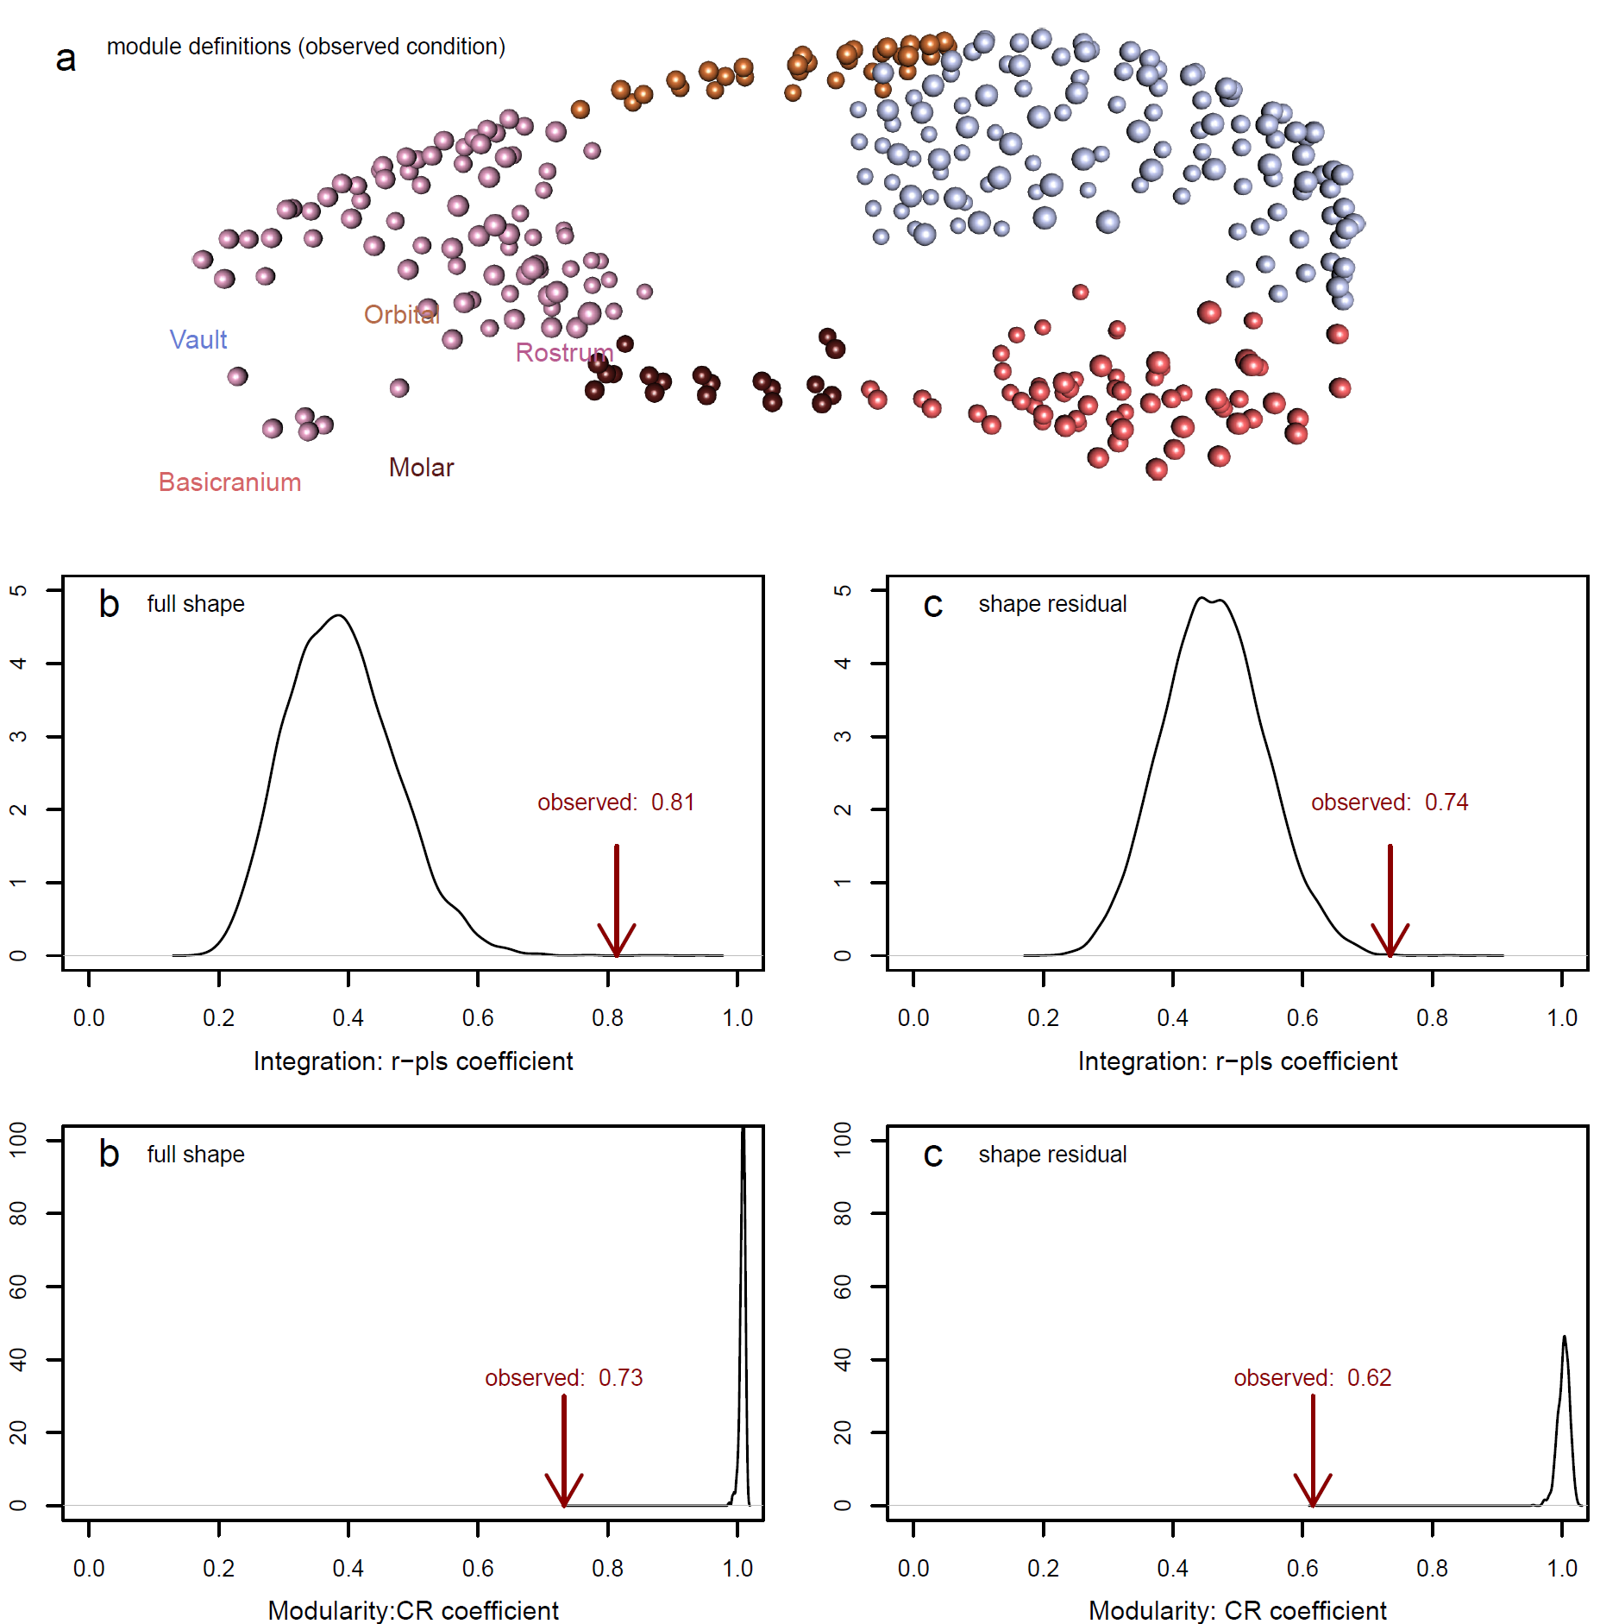

**Figure 4 Modularity tests using the CR coefficient**

**a** our five-module framework adapted from Goswami (2006). Results from the **b** full shape and **c** shape residual datasets. A CR coefficient of 1.0 indicates no modularity while decreasing values indicate increasing modularity. The observed CR value is compared to a distribution of 1,000 permutations in which the landmarks assigned to modules in **a** are randomly resampled.

**Table 1:** Modularity tests using pairwise Mantel comparisons of PCA-based distance matrices of all modules, and Mantel r statistic. An r statistic of 1 indicates a strong correlation and 0 indicates no correlation. The upper triangle reports statistics for pairwise comparisons between cranial modules of the full dataset, the lower triangle reports r statistics for the lower dataset. The values in brackets are *p* values, adjusted by Bonferroni (1936) corrections for multiple comparisons.

|  |  |  |  |  |  |
| --- | --- | --- | --- | --- | --- |
|  | **Basicran.** | **Molar** | **Orbital** | **Rostrum** | **Vault** |
| Basicranium | **64** | 0.514 (0.01) | 0.601 (0.01) | 0.719 (0.01) | 0.753 (0.01) |
| Molar | 0.367 (0.03) | **19** | 0.55 (0.01) | 0.625 (0.01) | 0.564 (0.01) |
| Orbital | 0.283 (0.06) | 0.348 (0.02) | **32** | 0.807 (0.01) | 0.731 (0.01) |
| Rostrum | 0.524 (0.02) | 0.624 (0.01) | 0.626 (0.01) | **86** | 0.762 (0.01) |
| Vault | 0.652 (0.01) | 0.45 (0.03) | 0.629 (0.01) | 0.699 (0.01) | **124** |



Overall, both modularity tests supported high covariation between modules and therefore low modularity (Fig. 4, Table 1). This is particularly evident in the CR coefficient tests, which accounted for unique transformations within the phylogeny, and in Mantel test-based analysis of the full shape dataset, which contains global allometric impacts on shape (Fig. 4b; Table 1a). Consistent with these results, the test of global integration found a regression slope below -1.0 (Beval_full = -1.64; Beval_residual = -1.55; Fig. S2), which indicates global integration across all cranial modules [14] in both datasets. This means integration or a high degree of covariation among all modules obscures any potential modular structure [13].

### Phylo-morphological distance

We devised phylo-morphological distance plots (Fig. 5) to assess whether the relationship between phylogenetic distance and morphological distances (i.e. Procrustes distances between the mean shapes of a species pair) differs in the shape residual dataset compared to the full shape. In general, morphological distance is expected to increase with increasing phylogenetic distance because, as integration patterns change over time, shape covariation patterns diverge [30]. As expected, all of the points closest to the origin (i.e. low phylogenetic *and* low morphological distances) are within-genus pairs. In the full shape dataset, maxima in morphological distances tend to increase with phylogenetic distance until reaching an apparent asymptote around 4.2 Ma since the last common ancestor. However, the highest divergence values involve distances of all species with the two large-bodied frugivores: *U. caudimaculatus* and the djintamoonga or black-footed tree rat (*Mesembriomys gouldii*, Gray, 1843) (Fig. 5a). These are ignored, then the dataset’s maximum morphological distance appears earlier, around 2 Ma. Furthermore, all pairs involving *Rattus*, the most recent radiation of native rodents,fall below the maximum morphological distance reached around 2 Ma by pairwise comparisons of older endemics (Fig. 5a); in other words, shape distances between *Rattus* and other Australian murids, which have divergence dates of around ten million years[**CORRECT?**], fall well within the range of morphological distances within murids. However, as noted in the methods, these results are subject to pseudoreplication because they include all possible pairwise combinations, such that each of the 37 species accounts for 36 data points. This can be seen in the vertical clustering, which represent pairwise comparisons between one species and other species with the same divergence time (Fig. 5).

The ‘allometry-free’ shape residual pairwise comparisons were similar to the full shape dataset, with overall lower morphological distances as expected from removing allometric shape variation. The removal of allometric differences between differently-sized species also has a marked effect on the spread of morphological distances at each divergence. Most conspicuously, removing allometry substantially reduces morphological distances between the large-bodied frugivores relative to other ecological specialists, so that the greatest distances between species is now at the time of divergence between the two semiaquatic, carnivorous species at 5.7 Ma (Fig. 5b). If the semiaquatic species are ignored, the remaining dataset’s maximum distances appear around 3.1 Ma, or pairwise comparisons between hopping *Notomys* species and close relatives in *Pseudomys*. Both plots show the greatest morphological divergences occurring within the old endemic species, not between more-distantly related species involving *Rattus* or *Mus*.

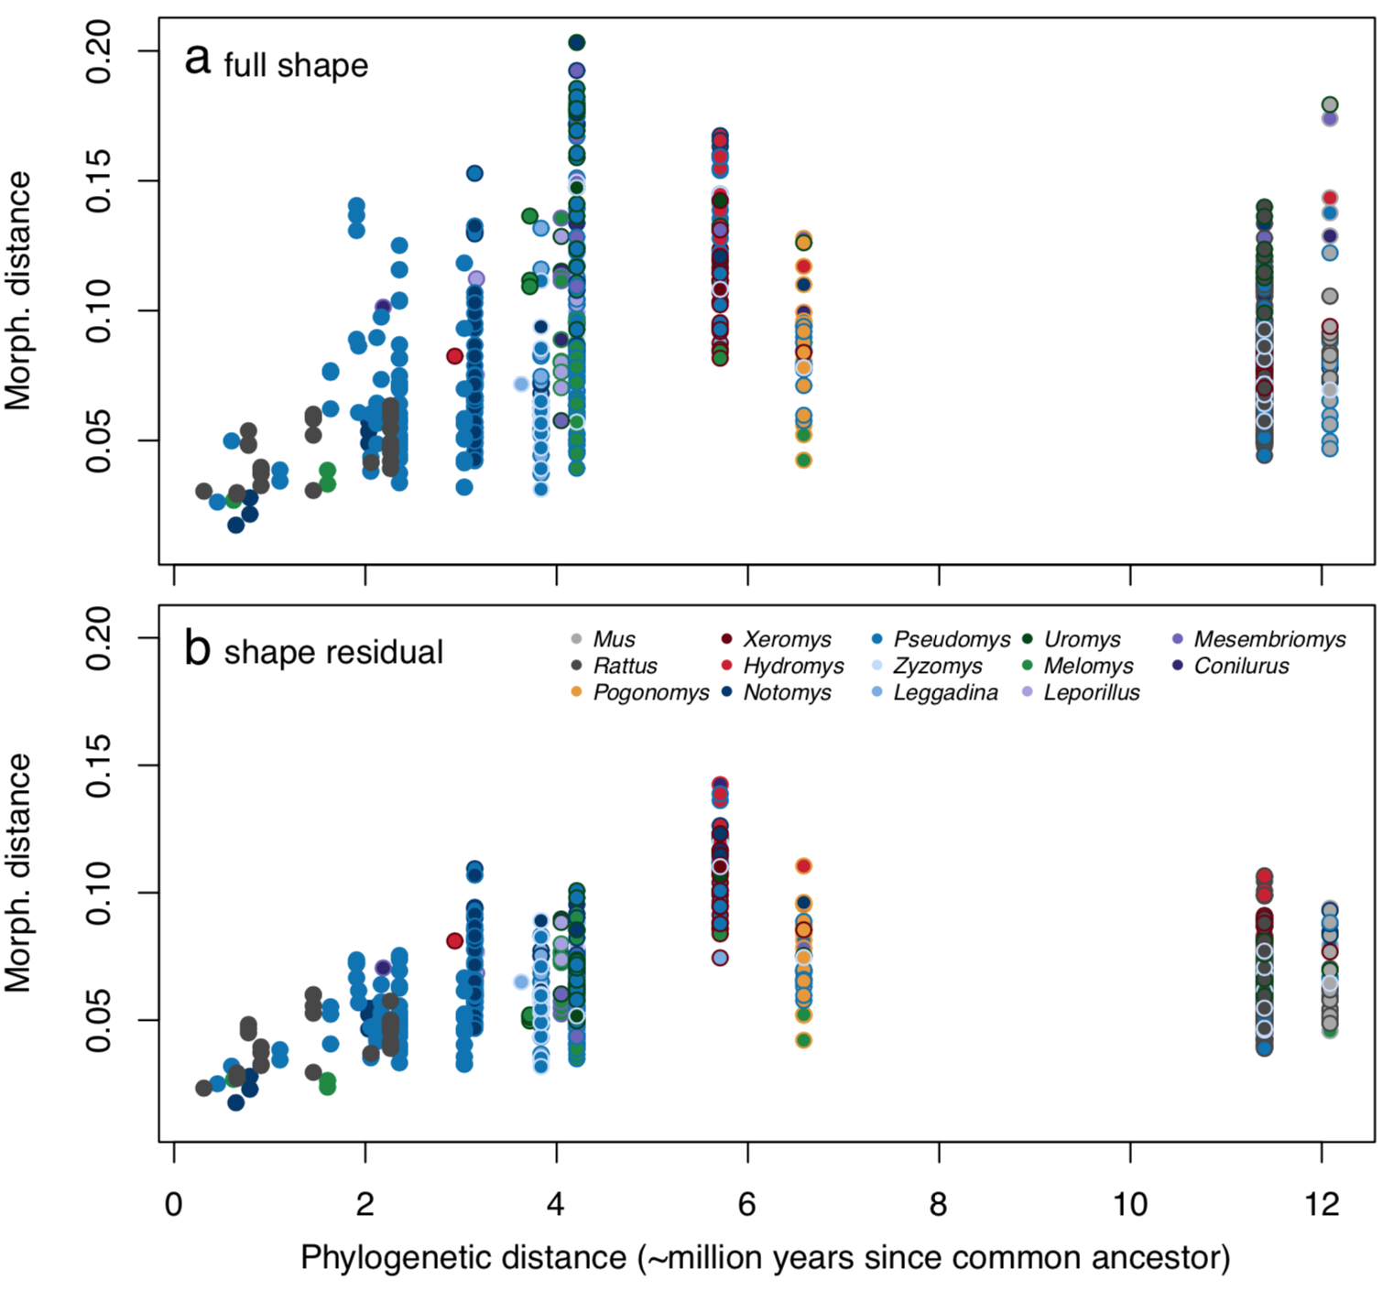

**Figure 5 Phylo-morphological distance plots**

Each point is a pairwise comparison with border and center colors corresponding to the two species’ genera. The x-axis is shared but the y-axes of morphological distances are not equivalent as they rely on different shape datasets: **a** full shape and **b** shape residual.

**Discussion**

In this study, we characterised the evolution of cranial shape beyond allometric patterns in a highly allometric clade of Australian murine rodents. As expected, removal of the allometric pattern indeed removes much of the shape variation of longer faces at larger sizes, which is commonly attributed to the ‘rule’ of craniofacial evolutionary allometry (CREA) [4, 31. However, a substantial part of the ordinated allometry-free shape variation – 18% - reflects differences in relative anterior braincase expansion, which are part of the CREA pattern but here appear independent of allometry. Thus, not unexpectedly [8, 9, 32], allometric patterning is not the only cause of shape variation that is commonly attributed to CREA. Removal of allometric effects thus can reveal other relevant patterns of shape variation. In the case of the murine pattern, it is possible that the brain of species with more expanded braincases along PC2 either have brain volumes that are larger than expected for their body mass – essentially reflecting the encephalization of these species (Smaers et al 2022) – or have a different distribution of the brain tissue within the braincase (Weisbecker et al. 2021) compared to lower-scoring species. This effect serves as a reminder that comparisons of allometric and ‘allometry-free’ datasets can identify how different sources of shape variation interact to produce visible patterns of vertebrate shape diversity, even in clades with strong allometric constraints.

Allometry in mammalian crania, and the subsequent shape variation as predicted by CREA, has often been attributed to the integration of size with masticatory biomechanics [5, 8, 9, 33 REX]. This is probably particularly true for rodents, where high levels of allometry likely reflect constraints imposed by their highly derived gnawing function [7, 10, 34–37]. However, the residual shape space also appears to have a biomechanical source of shape variation: the second allometry-free axis captured CREA-like variation in relative basicranium size, where the two most specialized folivore species showed shallower vaults than expected for their size. This pattern likely reflects the wider skulls and dorsally shifted temporalis muscles that increase the mechanical advantage for masticating fibrous foods, which has evolved in specialist folivores across several rodent families [38]. This further emphasizes the high importance of biomechanical adaptation in shaping the rodent skull, and also reinforces the interpretation of CREA-like patterns as deriving from biomechanically-driven scaling [2] [**REX, CAN YOU EXPAND/ALIGN HERE WITH PERSPECTIVES FROM THE REVIEW PAPER?].**

Under the assumptions of Mitchell et al. (202x)’s framework, the CREA pattern represents a tradeoff between bite force and alternative selective pressures that shift in importance with increasing size; and they posit that these alternative selective pressures are likely different for any given taxon of interest. In the case of rodents, there are potential benefits to increasing gape (Williams et al., 2009; Hennekam et al., 2020), which is possibly further evidenced by the carnivorous species with more elongate crania than expected for their size. By contrast, morphology related to biting biomechanics is also expected to be shaped over evolutionary time by the most strenuous foods consumed (van Valkenburgh, 1989; Strait et al., 2009; Figueirido et al., 2013; Mitchell, 2019), and frequent consumption of desert seeds and insects by the hopping generalist species (Notomys??; Murray et al., 1999) might explain their more robust cranial dimensions than expected for their size.

Despite evidence that the allometric pattern in our sample is strongly driven by stabilizing selection on mastication, it appears not to constrain the evolution of other important adaptations such as postural variation coinciding with ecological specializations. For example, the rabbit rat (*Conilurus penicillatus*) has the highest facial tilt of the sample, consistent [12] with its quadrupedally bounding locomotion [39]. However, despite its unusual shape, the rabbit rat still falls along the common allometric line, thus suggesting that any stabilizing selection on mastication also permits the evolution of specialist postures. A similar pattern is seen in the bipedally hopping genus *Notomys*, whichis second in facial tilt to *Conilurus*, and to a lesser degree in *Mastacomys*. *Notomys* species do not lie on the common allometric line, but this separation is because of their derived basicranium, not their facial tilt. The inclusion of a facial tilt in *Conilurus* and *Notomys* within the common allometric pattern therefore suggests a level of flexibility to adaptations that do not interfere with masticatory function.

Visual assessment of the non-allometric shape variation provides intriguing evidence that even apparently non-allometric variation may have its origins in an underlying allometric pattern. In particular, the allometry-free PC2 axis – capturing “partial” CREA-like variation of relative braincase size – differentiates species that are adapted for different functions. Specifically, specialized folivory for the broad-toothed rat *Mastacomys*, which lies above the common allometric line, and bipedal hopping for *Notomys*, which lies below this line. In terms of shape, *Mastacomys* displays a cranial shape like a larger murid, by having a relatively smaller braincase relative to the snout region; this is consistent with descriptions of its unusually robust skull [15]. By contrast, *Notomys* displays a larger braincase region relative to the snout, as would be expected for a smaller murid. Since the allometric slopes of *Notomys* and *Mastacomys* are not significantly different from the common allometric slope [7], the changes in braincase dimension appear to reflect a “grade shift” of an otherwise identical allometric pattern. Thus, in a group with a constrained allometric slope, changing the multidimensional regression-score intercept of species- or genus-level trajectories might represent a pathway towards cranial diversity that remains consistent with a general allometric constraint. [**REX, THIS IS ALSO SOMETHING YOU CAN ALIGN WITH THE REVIEW**]

IF I’M UNDERSTANDING THIS RIGHT, This pattern found for braincase size is similar to the arguments made for facial elongation by Mitchell et al. (202x), whereby speciation of a distinct ecomorph within a clade will subsequently follow a CREA-like pattern within the bounds of its novel function, and often independently parallel the basal CREA pattern within the phylogeny.

Counter to our expectations, the allometric and non-allometric distances among species did not correspond with increases in phylogenetic distances. Instead, the asymptotic divergence pattern of shape through time is consistent with a size-related constraint on cranial shape. However, instances of maximum divergence within the sample correspond with our three proposed mechanisms for the evolution of shape variation in Australian murids. First, the maximum divergence in the full shape dataset involves the large-bodied frugivores, whose cranial shapes were probably facilitated by an allometric line of least resistance honed by stabilizing selection (*sensu* [7, 40]). In contrast, the allometry-free maximum divergence highlights the shape distances we hypothesize occurred due to a carnivory-related release from this selection on masticatory function. Finally, the second-highest divergence in the allometry-free shape analysis involving the hopping *Notomys* likely reflects the aforementioned change in the genus-level allometric multidimensional intercept. Overall, the pattern of “spikes” of divergence in otherwise limited morphospace (as demonstrated by a plateau of diversification after 4.2-5.7 million years) suggests an evolutionary pattern most consistent with a mean-shift Ornstein-Uhlenbeck process of limited diversification around a local optimum [41].

Our analyses strongly suggest that biomechanical functionality of mastication (and potentially posture) are the primary drivers of both allometric and non-allometric shape variation in the crania of Australian murines. This might also explain why the cranium displays low modularity, but high overall integration, in the full and residual dataset. Constraints are widely held to translate into high levels of integration in the cranium [Goswami], and allometric patterns are commonly attributed to the action of a constraint (reviewed in Marcy, Mitchell). However, in the case of murines, constraints appear to extend beyond the allometric pattern and instead relate to a more global constraint. Specifically for murines, the low modularity and high integration reinforces previous interpretations that rodent crania are under strong stabilizing selection related to their derived masticatory apparatus, of which allometric patterns are just one manifestation. This also fits with the observation that rodents occupy a highly distinct, slowly-evolving area in the morphospace of placental crania (Goswami Science paper). More generally, this interpretation supports suggestions that allometric patterns need to be interpreted in the context of other variation, even when allometry explains the majority of shape variation (Mitchell).

**Conclusions**

Contrasting the shape spaces of Australian rodent with and without the allometric component provides an intriguing perspective on the role of size in the functional evolution of the rodent - and possibly mammalian - cranium. One important insight is that some patterns of postural adaptation, in our case relating to facial tilt, appear to be integrated with a common allometric line, producing a shared evolutionary shape pattern for the majority of the diverse sample. This suggests that the CREA pattern, according to which rodent crania evolve, is a one-to-many pattern that can incorporate diverse cranial functionalities. It is particularly interesting that we find some evidence grade shift in shape, for some of the specialized species, which results in apparently non-allometric variation but might just reflect an intercept shift of the common allometric slope. As such, our data provide a strong impression that true deviations from the biomechanically tightly integrated cranial evolution of rodents is to be expected in species with substantially different masticatory mechanism to that of most murid rodents, for example, hystricomorphs or worm-specialists like *Paucidentomys* [42]. Overall, therefore, our study shows that co-interpretation of allometric patterns with overall assessments of cranial function and integration are a promising path towards a detailed assessment of cranial evolution in mammals[**TO BE IMPROVED**].

**Declarations**

**Ethics approval and consent to participate:** Not applicable.

**Consent for publication:** Not applicable.

**Availability of data and materials:** The dataset of 3D specimen scans analyzed during the current study are available in the MorphoSource repository (https://www.morphosource.org/projects/00000C561). The dataset of landmark coordinates and the fully reproducible code for the analyses in the current study are available on GitHub (<https://github.com/miracleray/eco-rodents>).

**<CITATIONS NEEDED>**

**Competing interests:** The authors declare that they have no competing interests.

**Funding:** Discovery Grant DP170103227 to VW and MP, CE170100015

FT180100634 to VW. No funding sources were involved in the design of study; nor in the collection, analysis, and interpretation of data; nor in the writing of the manuscript.

**Authors’ contributions:** AEM and VW conceived the original idea. AEM collected the data. AEM analyzed the data with support from TG and VW. AEM wrote the manuscript with support from VW, TG, and MJP. VW and MJP provided supervision on the project.

**Acknowledgements:** We thank Dr Heather Janetzki for hosting AEM many times in the mammal collections at the Queensland Museum, Laura Cook for hosting at the Museum Victoria, Dr Sandy Ingleby for hosting at the Australian Museum, and Dr David Stemmer for loaning specimens from the South Australian Museum. Thanks to lab assistants Aubrey Keirnan and Lauren Thornton for help uploading 3D scans to Morphosource. Thanks to Dr Gabriele Sansalone for consulting on integration analysis. Thanks to Dr Gilbert Price for providing comments on an early draft.

**Authors’ information <DECIDE>**

**References**

1. Cardini A, Polly D, Dawson R, Milne N. Why the Long Face? Kangaroos and Wallabies Follow the Same ‘Rule’ of Cranial Evolutionary Allometry (CREA) as Placentals. Evol Biol. 2015;42:169–76.

2. Cardini A, Polly PD. Larger mammals have longer faces because of size-related constraints on skull form. Nat Commun. 2013;4:1–7.

3. Bright JA, Marugán-Lobón J, Cobb SN, Rayfield EJ. The shapes of bird beaks are highly controlled by nondietary factors. PNAS. 2016;113:5352–7.

4. Cardini A. Craniofacial Allometry is a Rule in Evolutionary Radiations of Placentals. Evol Biol. 2019;46:239–48.

5. Marroig G, Cheverud JM. Size as a line of least evolutionary resistance: diet and adaptive morphological radiation in new world monkeys. Evolution. 2005;59:1128–42.

6. Marroig G, Cheverud J. Size as a line of least resistance II: direct selection on size or correlated response due to constraints? Evolution. 2010;64:1470–88.

7. Marcy AE, Guillerme T, Sherratt E, Rowe KC, Phillips MJ, Weisbecker V. Australian Rodents Reveal Conserved Cranial Evolutionary Allometry across 10 Million Years of Murid Evolution. The American Naturalist. 2020;196:755–68.

8. Mitchell DR, Sherratt E, Ledogar JA, Wroe S. The biomechanics of foraging determines face length among kangaroos and their relatives. Proceedings of the Royal Society B: Biological Sciences. 2018;285:20180845.

9. Weisbecker V, Guillerme T, Speck C, Sherratt E, Abraha HM, Sharp AC, et al. Individual variation of the masticatory system dominates 3D skull shape in the herbivory-adapted marsupial wombats. Frontiers in Zoology. 2019;16:41.

10. Druzinsky RE. The oral apparatus of rodents: variations on the theme of a gnawing machine. In: Cox PG, Hautier L, editors. Evolution of the Rodents: Advances in Phylogeny, Functional Morphology and Development. Cambridge: Cambridge University Press; 2015. p. 323–49.

11. Fabre P-H, Herrel A, Fitriana Y, Meslin L, Hautier L. Masticatory muscle architecture in a water-rat from Australasia (Murinae, *Hydromys*) and its implication for the evolution of carnivory in rodents. Journal of Anatomy. 2017;231:380–97.

12. Kraatz B, Sherratt E. Evolutionary morphology of the rabbit skull. PeerJ. 2016;4:e2453.

13. Klingenberg CP. Morphometric integration and modularity in configurations of landmarks: tools for evaluating a priori hypotheses. Evolution & Development. 2009;11:405–21.

14. Bookstein FL. Integration, Disintegration, and Self-Similarity: Characterizing the Scales of Shape Variation in Landmark Data. Evol Biol. 2015;42:395–426.

15. Breed B, Ford F. Native Mice and Rats. CSIRO Publishing; 2007.

16. Oksanen J, Blanchet FG, Friendly M, Kindt R, Legendre P, McGlinn D, et al. *vegan*: Community Ecology Package. 2019. https://CRAN.R-project.org/package=vegan.

17. Guillerme T, Weisbecker V. *landvR*: Tools for measuring landmark position variation. R package version 0.4. 2019. doi:10.5281/zenodo.2620785.

18. Goswami A. Cranial Modularity Shifts during Mammalian Evolution. The American Naturalist. 2006;168:270–80.

19. Adams DC. Evaluating modularity in morphometric data: challenges with the RV coefficient and a new test measure. Methods in Ecology and Evolution. 2016;:565–72.

20. Adams DC, Collyer ML. Comparing the strength of modular signal, and evaluating alternative modular hypotheses, using covariance ratio effect sizes with morphometric data. Evolution. 2019;73:2352–67.

21. Adams DC, Felice RN. Assessing trait covariation and morphological integration on phylogenies using evolutionary covariance matrices. PLoS One. 2014;9:e94335.

22. Smissen PJ, Rowe KC. Repeated biome transitions in the evolution of Australian rodents. Molecular Phylogenetics and Evolution. 2018;128:182–91.

23. Klingenberg CP, Marugán-Lobón J. Evolutionary Covariation in Geometric Morphometric Data: Analyzing Integration, Modularity, and Allometry in a Phylogenetic Context. Syst Biol. 2013;62:591–610.

24. Legendre P, Legendre L. Numerical Ecology. 3rd English Edition. Elsevier; 2012.

25. Hetherington AJ, Sherratt E, Ruta M, Wilkinson M, Deline B, Donoghue PCJ. Do cladistic and morphometric data capture common patterns of morphological disparity? Palaeontology. 2015;58:393–9.

26. Bonferroni CE. Teoria statistica delle classi e calcolo delle probabilità. Pubblicazioni del R Istituto Superiore di Scienze Economiche e Commerciali di Firenze. 1936;:1–62.

27. Kembel SW, Cowan PD, Helmus MR, Cornwell WK, Morlon H, Ackerly DD, et al. *Picante*: R tools for integrating phylogenies and ecology. Bioinformatics. 2010;26:1463–4.

28. Aplin K, Ford F. Murine rodents: late but highly successful invaders. In: Prins HHT, Gordon IJ, editors. Invasion Biology and Ecological Theory: Insights from a Continent in Transformation. 1st edition. Cambridge: Cambridge University Press; 2014. p. 196–240.

29. Sansalone G, Colangelo P, Loy A, Raia P, Wroe S, Piras P. Impact of transition to a subterranean lifestyle on morphological disparity and integration in talpid moles (Mammalia, Talpidae). BMC Evolutionary Biology. 2019;19:179.

30. Voje KL, Hansen TF, Egset CK, Bolstad GH, Pélabon C. Allometric constraints and the evolution of allometry. Evolution. 2014;68:866–85.

31. Radinsky LB. Approaches in Evolutionary Morphology: A Search for Patterns. Annu Rev Ecol Syst. 1985;16:1–14.

32. Viacava P, Blomberg SP, Sansalone G, Phillips MJ, Guillerme T, Cameron SF, et al. Skull shape of a widely distributed, endangered marsupial reveals little evidence of local adaptation between fragmented populations. Ecology and Evolution. 2020;10:9707–20.

33. Singleton M. Functional Shape Variation in the Cercopithecine Masticatory Complex. In: Slice DE, editor. Modern Morphometrics in Physical Anthropology. Boston, MA: Springer US; 2005. p. 319–48. doi:10.1007/0-387-27614-9_15.

34. Lessa EP, Patton JL. Structural constraints, recurrent shapes, and allometry in pocket gophers (genus Thomomys). Biological Journal of the Linnean Society. 1989;36:349–63.

35. Cox PG, Rayfield EJ, Fagan MJ, Herrel A, Pataky TC, Jeffery N. Functional Evolution of the Feeding System in Rodents. PLOS ONE. 2012;7:e36299.

36. Marcy AE, Hadly EA, Sherratt E, Garland K, Weisbecker V. Getting a head in hard soils: Convergent skull evolution and divergent allometric patterns explain shape variation in a highly diverse genus of pocket gophers (*Thomomys*). BMC Evolutionary Biology. 2016;16:207.

37. Ginot S, Claude J, Hautier L. One skull to rule them all? Descriptive and comparative anatomy of the masticatory apparatus in five mouse species. Journal of Morphology. 2018;279:1234–55.

38. Samuels JX. Cranial morphology and dietary habits of rodents. Zool J Linn Soc. 2009;156:864–88.

39. Kemper CM. Muridae. In: Richardson B, Walton D, editors. Fauna of Australia. Australian Government Publishing Service, Canberra; 1989. p. 35.

40. Schluter D. Adaptive radiation along genetic lines of least resistance. Evolution. 1996;50:1766–74.

41. Harmon, L. J., J. B. Losos, T. J. Davies, R. G. Gillespie, J. L. Gittleman, W. B. Jennings, K. H. Kozak, M. A. McPeek, F. Moreno-Roark, T. J. Near, A. Purvis, R. E. Ricklefs, D. Schluter, J. A. S. Ii, O. Seehausen, B. L. Sidlauskas, O. Torres-Carvajal, J. T. Weir, and A. Ø. Mooers. 2010. Early Bursts of Body Size and Shape Evolution Are Rare in Comparative Data. Evolution 64:2385–2396.

42. Esselstyn, J. A., A. S. Achmadi, and K. C. Rowe. 2012. Evolutionary novelty in a rat with no molars. Biology Letters 8:990–993.

**Supporting Information**

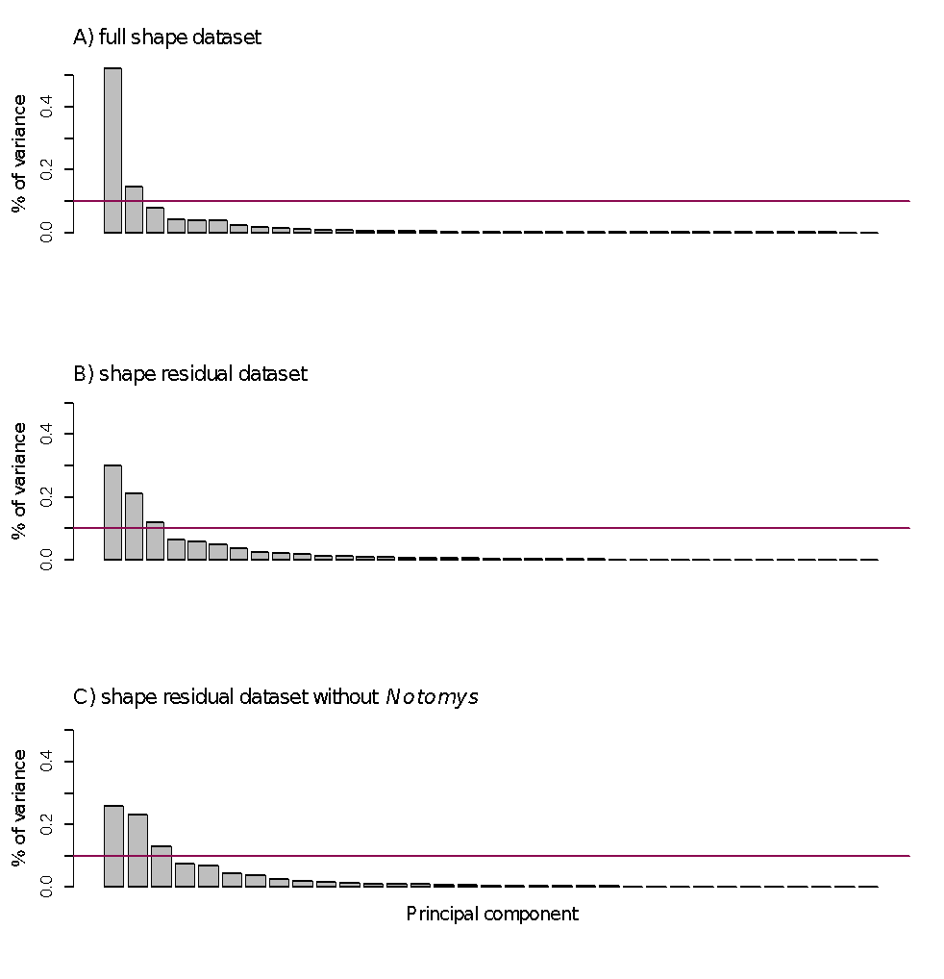**Figure0S1 Scree plots for PCAs on the three main datasets**

Scree plots show the proportion of variance explained by each individual PC. The pink line indicates 10%. The scree plot for (A) the full shape dataset with allometry, (B) the shape residual dataset (size-free or allometry-free), and (C) the shape residual dataset without *Notomys*.

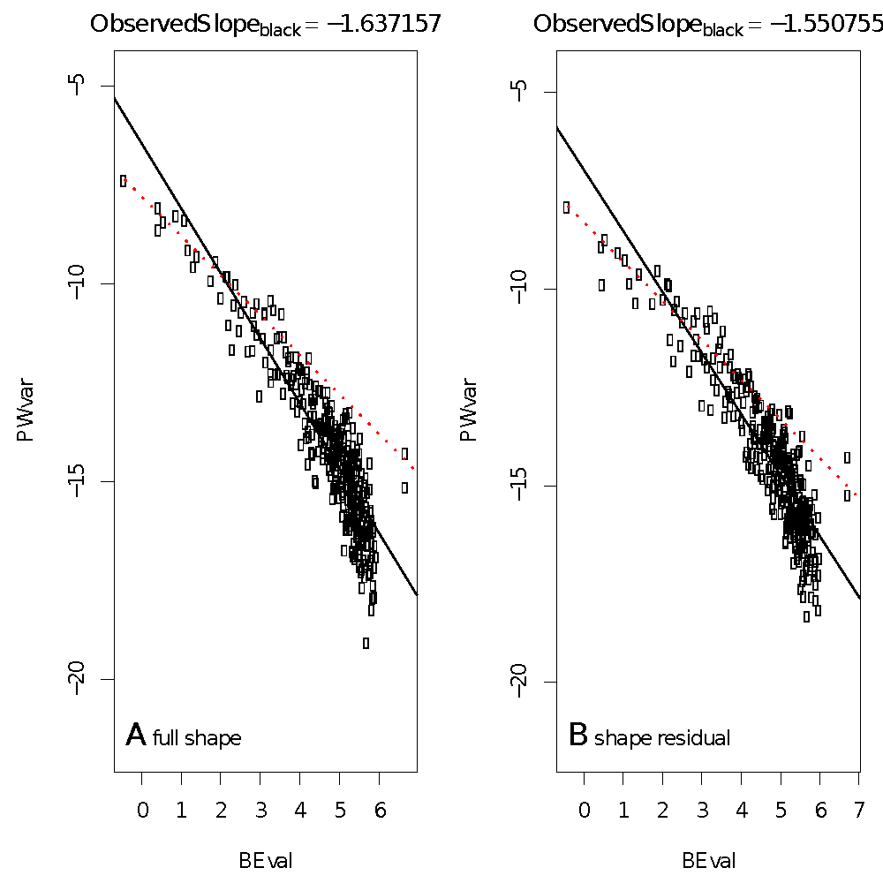

**Figure0S2 Tests for global integration**

A plot of log bending energy (BEval) versus the log partial warp variance (PWvar) for our specimens, that using the method from Bookstein (2015), can distinguish global integration from self-similarity. The red line represents the null hypothesis for self-similarity with a regression slope of exactly -1 against the observed regression slopes for the (A) full shape and (B) shape residual datasets. The steeper observed slopes in both support hypotheses for global integration.